How to check Apprentice Monthly Progress Reports

FlashPoint
Logging into your account on FlashPoint
- Log into FlashPoint using the following URL: http://workforce.flashpoint.xyz/Auth/Login
- Forgot your password? Click the link and you will be sent an e-mail that will allow you to make a new password
- Forgot your log in e-mail? Call Kimberly at 503-598-0522 and she can figure that out for you. You will be sent a temporary password e-mail:
SUBJECT: Temporary Password
Your system login has been established.
Your account has been assigned a temporary password which you will need to change when you next login.
To access the system, please navigate to http://workforce.flashpoint.xyz/Auth/Login and use the following credentials:
Username: xxxxxxxxxx@email.com
Password: xxxxxxxx

- Click on the URL link provided in the email: http://workforce.flashpoint.xyz/Auth/Login
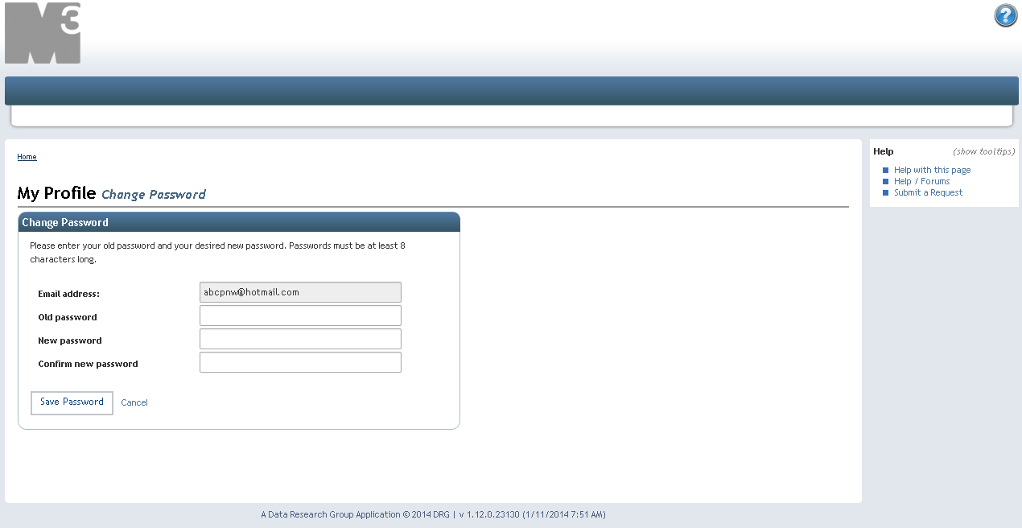

- Once you open the URL link you will then be asked to enter your email address and your ‘old’ password – here you will enter the temporary password that was provided in the email
- Then create a password that you will be able to remember and click Save Password

GENERAL INFO ABOUT MONTHLY PROGRESS REPORTS
- Employers are required to authorize MPRs for each apprentice every month
- MPRs are to be entered by the apprentice on-line by the 10th of every new month including summer months and must be approved by the employer by the end of that month
- It is recommended that apprentices keep a copy of their pay stubs for their own records
- The purpose of the work process categories on the MPR is to ensure that an apprentice receives on-the-job experience in all aspects of the trade

APPROVING MPRS STEP-BY-STEP
- From the dashboard, select: My Company

- You will then be directed to the list of Work Reports that have been submitted

- Review the hours worked for each apprentice to ensure accuracy
- To approve MPRs, select each apprentice to approve and click Approve Selected
- You can change the status on the right to see all previously approved months
- It is also important to check the distribution of hours for each apprentice (next page)

Checking MPR Categories For An Apprentice
- From the dashboard, select: My Company, then Hours
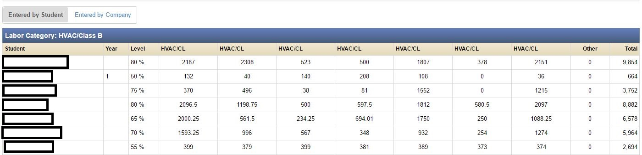

- You can see each apprentice and how many total hours they logged in each category - please review for accuracy

- Hovering your mouse over the column heading will show the title of that category
- This screen also shows their current percentage on the wage scale in the Level column
Checking School Progress
- By clicking on a specific apprentice, you can also check their status in school by keeping track of which classes have been passed and if any incompletes have been made up

